Spring 2018
SBI Membership Agreement

This membership agreement hereby makes me, a member of the SDSU Sports Business Initiative. By meeting all of the requirements to be a part of this organization, paying the full amount of dues, and regularly attending meetings, I will be recognized by Student Life and Leadership as a regular member of SBI.

The dues to be a member of this organization are a total cost of $30. These dues will get me an SBI shirt, pad folio, exclusive opportunities with Sports Business Summit executives, and site visits.
President
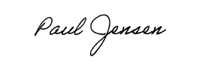
Paul Jensen
Printed Name:
Signature: Date:_______
Shirt Size (Circle One): S | M | L | XL|2XL
E-mail:
RedID:________________________________

President

Paul Jensen

